**23CSE111**

**OBJECT-ORIENTED PROGRAMMING**

**LAB REPORT**



**Department of Computer Science Engineering**

**Amrita School of Computing**

**Amrita Vishwa Vidyapeetham, Amaravati Campus**

**VERIFIED BY: NAME: K. MANASA**

**ROLL NO: AV.SC.U4CSE24206**

**WEEK 01**

**PROGRAM-1:**

**AIM:** Download and Install Java Software

**PROCEDURE:**

**Step 1: Download JDK 21**

1. Open your web browser and go to the Oracle JDK Downloads page
2. Scroll down to the Java SE Development Kit 21 section.
3. Choose the Windows x64 Installer version.
4. Click on Download, then Wait for the download to complete**.**

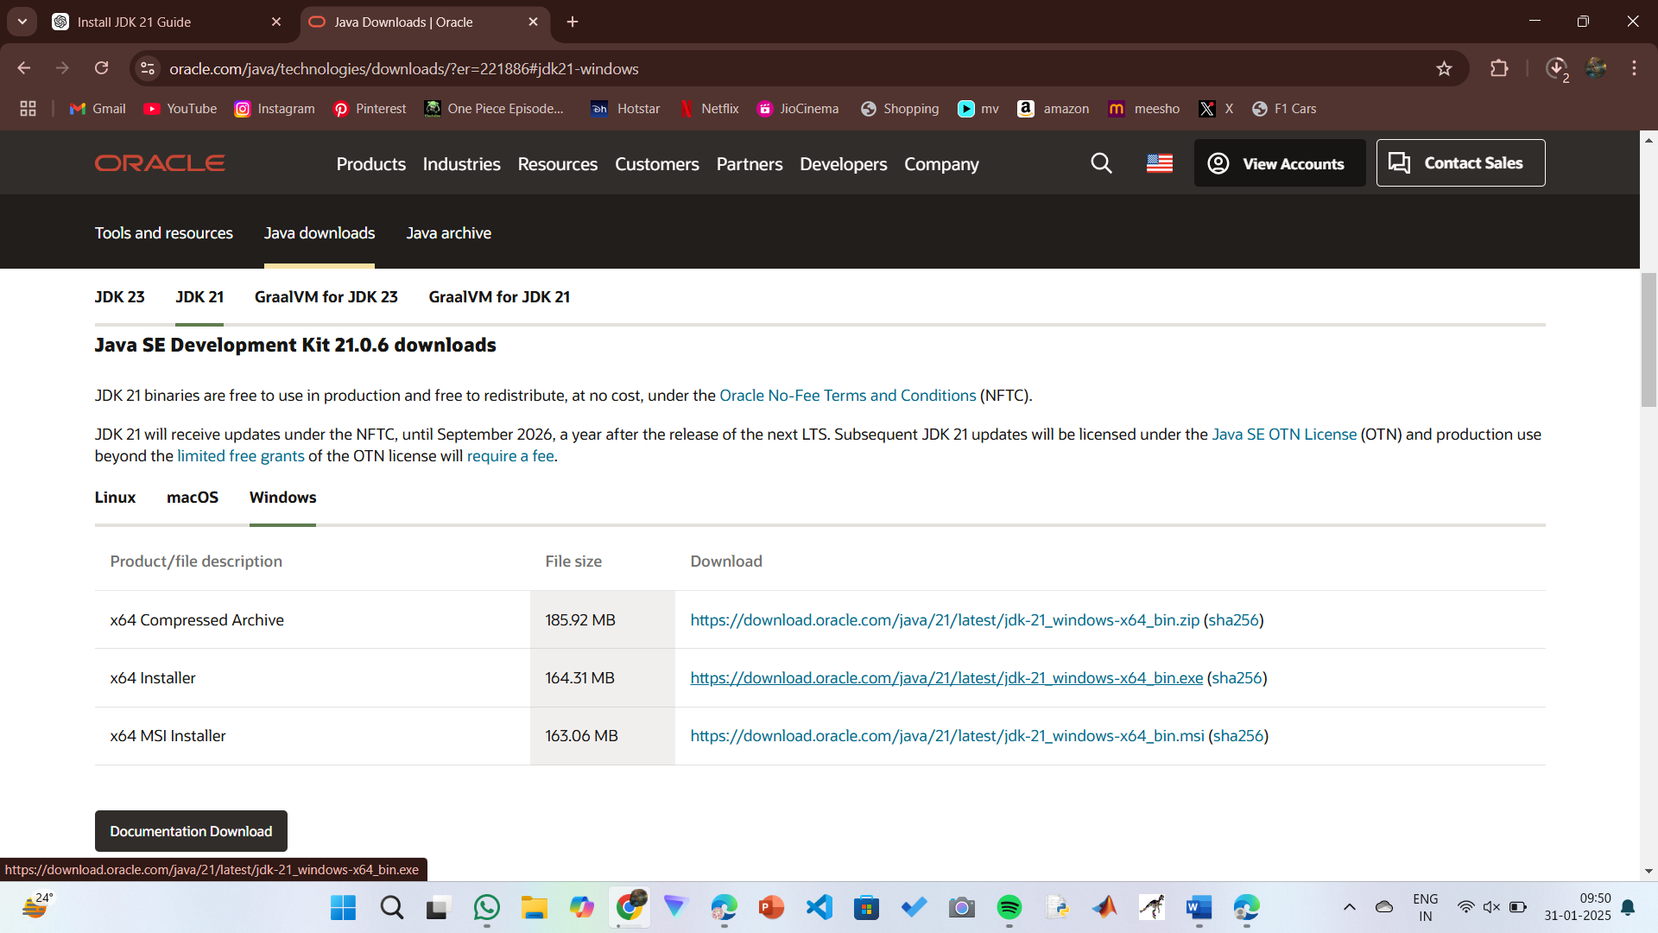

**Step 2:** **Install JDK 21**

1. Locate the downloaded jdk-21_windows-x64_bin.exe file.
2. Double-click to launch the installer.
3. Click Next on the setup wizard.
4. Choose the installation path (default is C:\Program Files\Java\jdk-21).
5. Click Next, then click Install.
6. Wait for the installation to complete.
7. Click Close once the installation is finished.

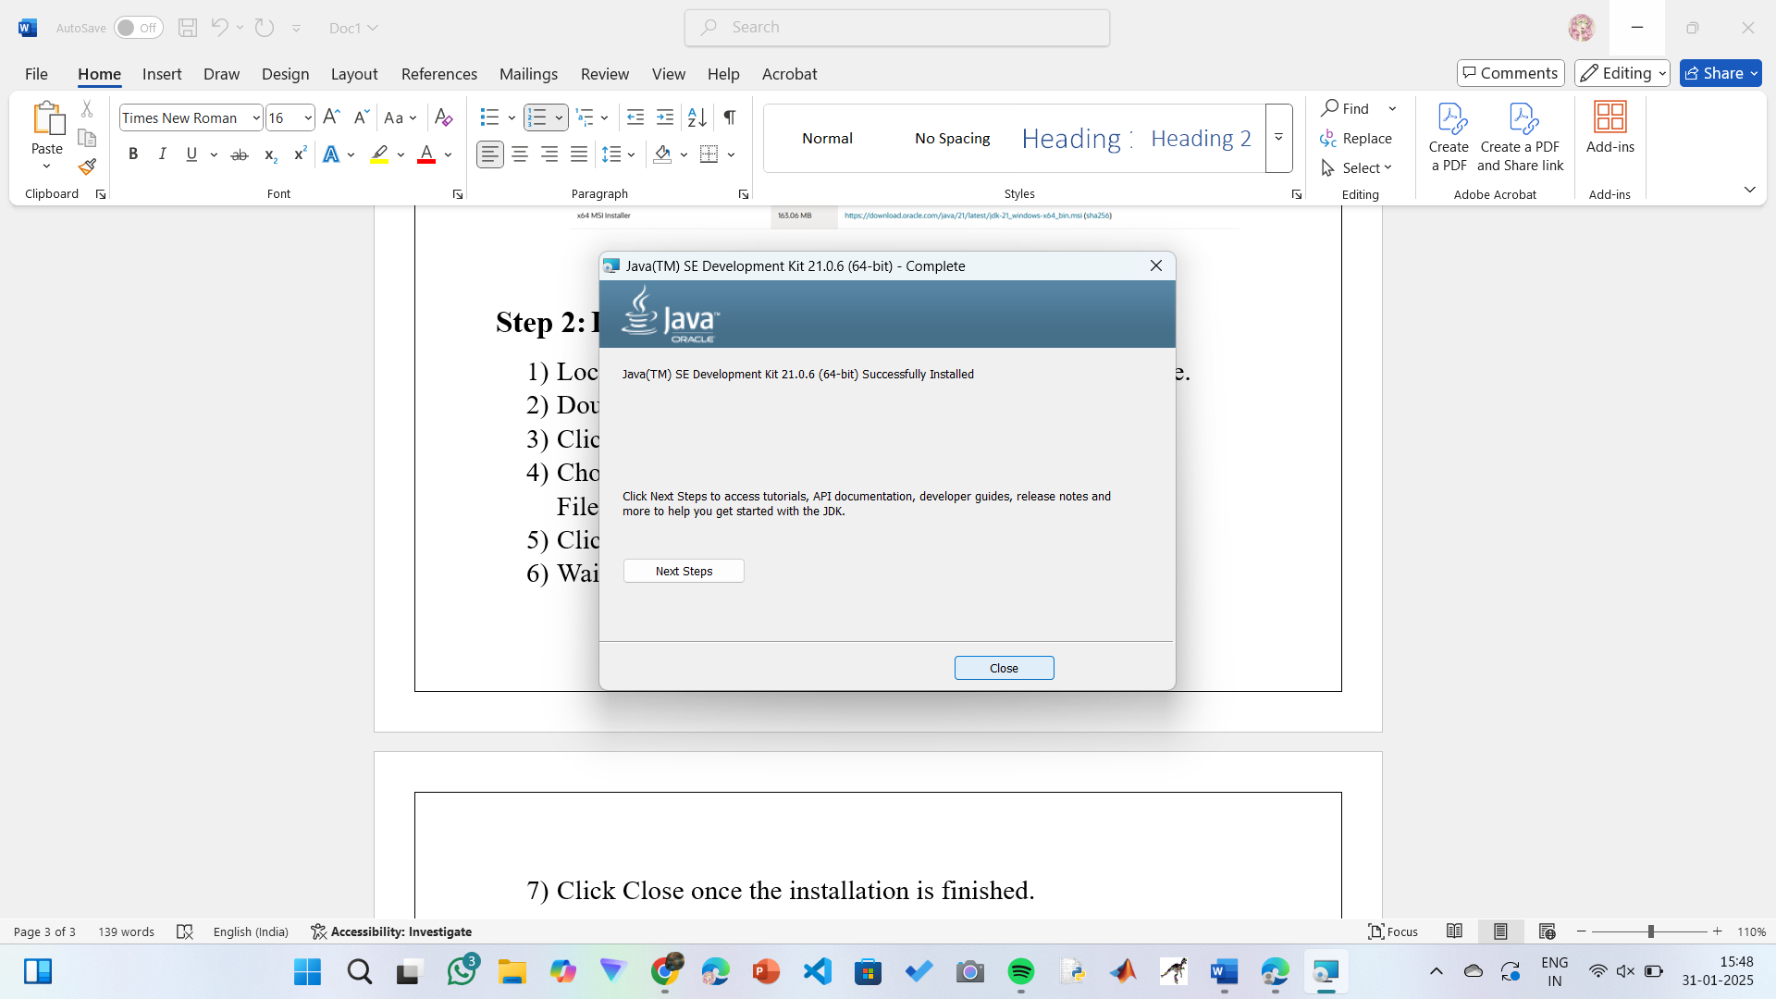

**Step 3: Setting up the path**

1) Go to “Windows C” Drive on Desktop

2) Choose Program Files, select Java, then JDK 21, then select Bin.

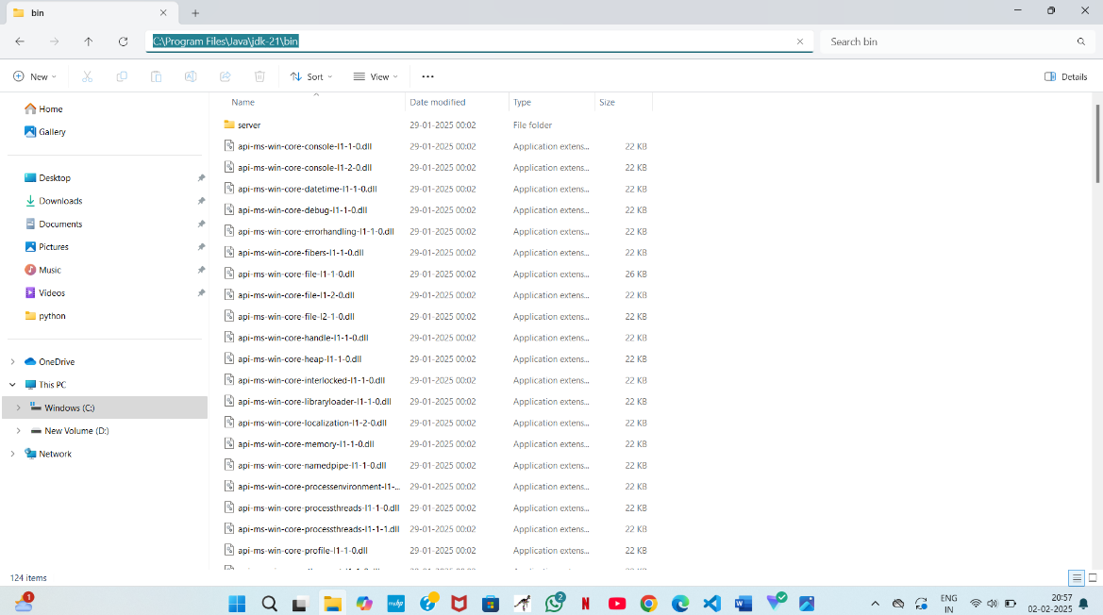 3) Select and copy the path at the address bar.

**Step 4: Open System Properties**

1. Press Windows + R, type sysdm.cpl, and click Ok-
2. The System Properties window will open.
3. Navigate to the Advanced tab.
4. 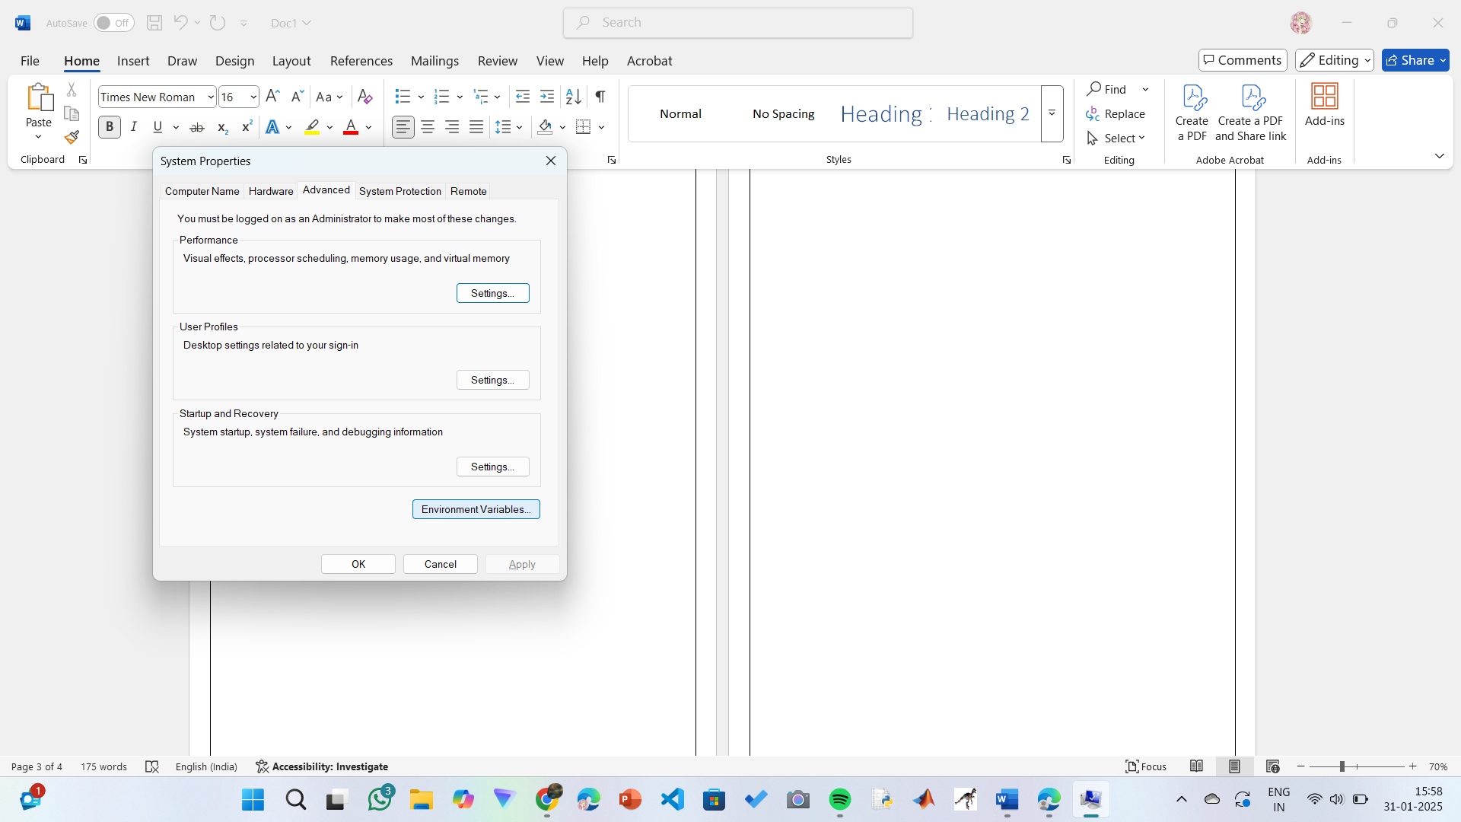Click on Environment Variables at the bottom.

**Step 5: Set JAVA_HOME**

1)Under System Variables, click New.

2)Set the Variable name as JAVA_HOME.

3)Set Variable value as C:\Program Files\Java\jdk-21 (or your installation path).

4)Click OK.

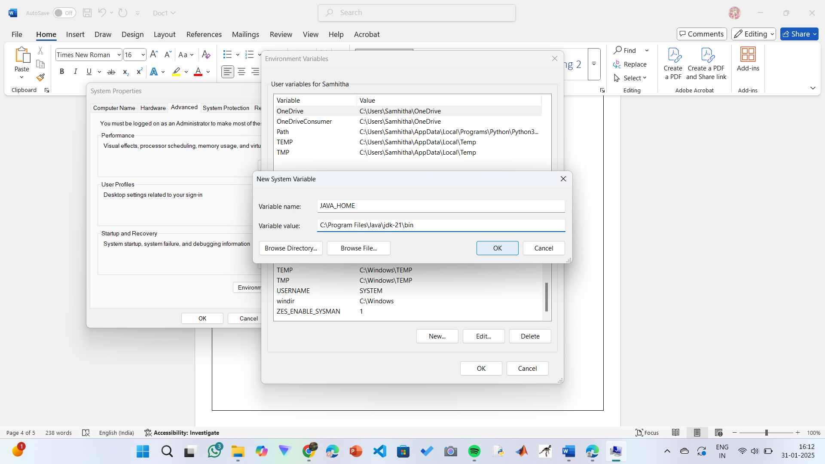

**Step 6: Update PATH Variable**

1)In System Variables, find Path and click Edit.

2)Click New and add: C:\Program Files\Java\jdk-21\bin

3)Click OK to save.

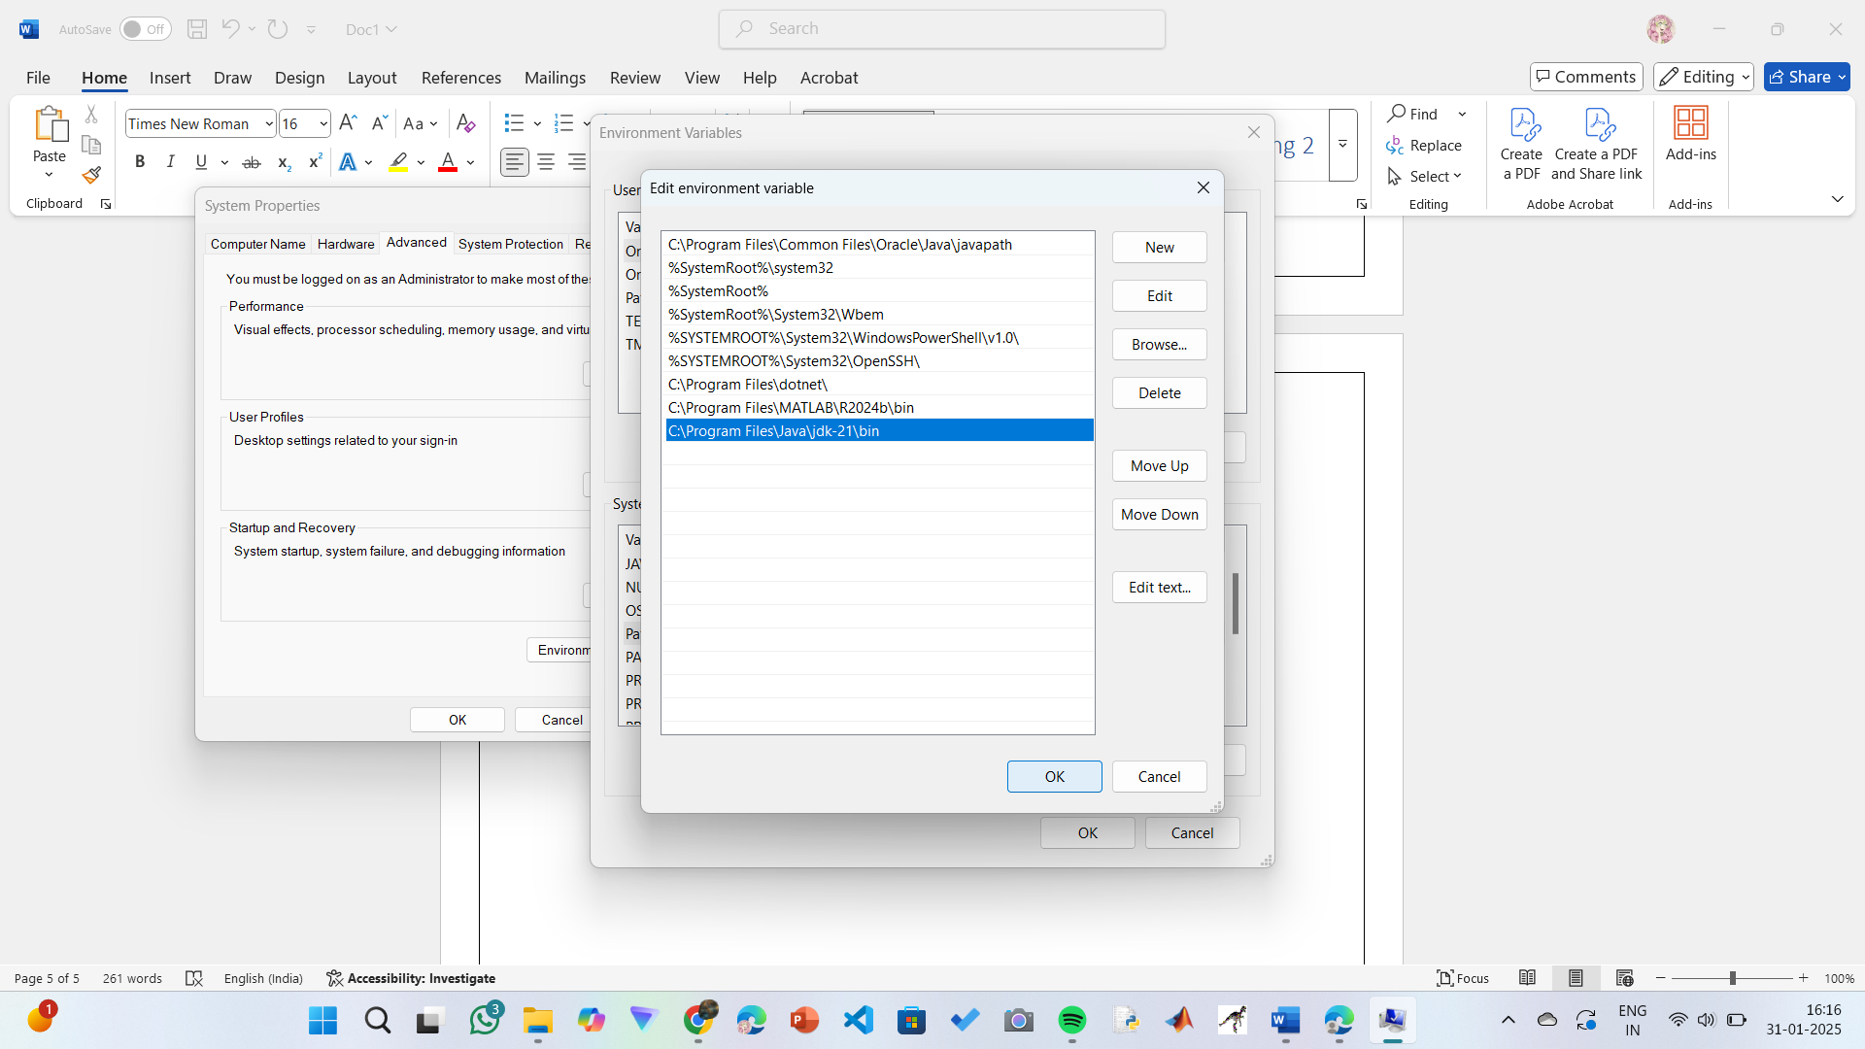

**Step 7:Verify Installation**

1. Open Command Prompt.
2. Type the following command: **java --version** and press Enter.

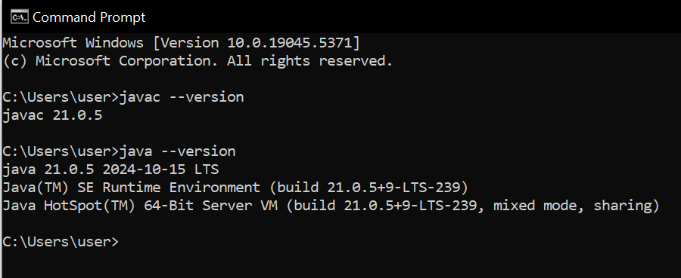

**PROGRAM-2:**

**AIM:** Write a Java program to print the message Hello World

”

**CODE:**

Public class helloworld {

public static void main (String [] args) {

System. out. println ("Helloworld");

}

}

**OUTPUT:**

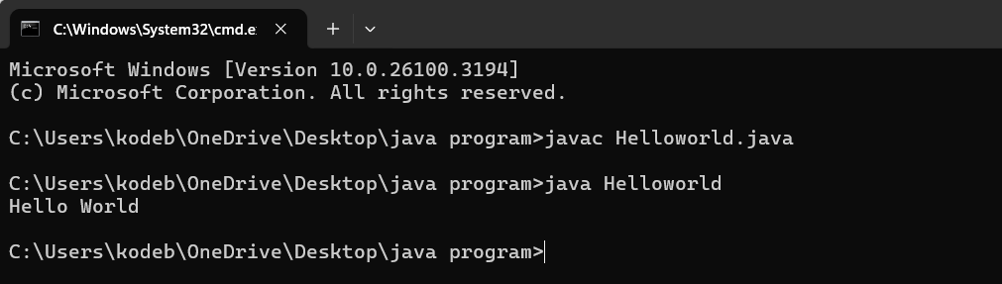

**ERRORS:**

|  |  |
| --- | --- |
| Error found | Error rectified |
| The class name should be in capital letter | Mention the first letter of the class name by capital letter |

**PROGRAM-3:**

**AIM:** Write a Java Program that prints Name, Roll No, Section of a student.

**CODE:**

class studentdetails{

public static void main (String [] args) {

System.out.println("Name: K.Manasa");

System.out.println("Section: CSE-C");

System.out.println("Roll no:AV.SC.U4CSE24206");

}

}

**OUTPUT:**

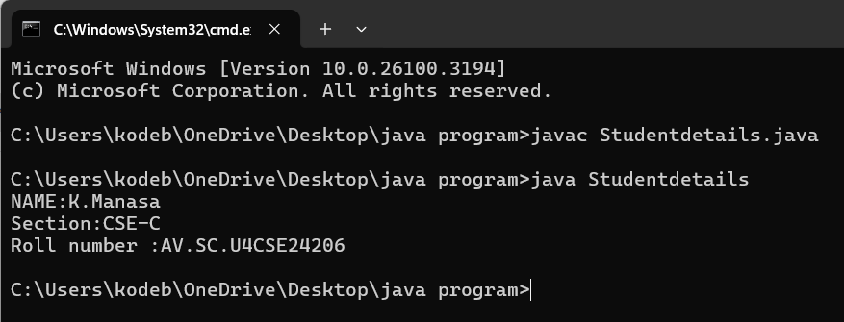

**ERRORS:**

|  |  |
| --- | --- |
| Error found | Error rectified |
| Studentdetails.java:2: error: cannot find symbol  public static void main(string args[]) {  ^  symbol: class string  location: class Studentdetails | public static void main (String [] args) { |

**WEEK 02**

**PROGRAM-1:**

**AIM:** Write a Java program to calculate area of rectangle and area of triangle using herons formula.

**CODE:**

import java.util.Scanner;

class Area {

public static void main(String[] args) {

Scanner input = new Scanner(System.in);

System.out.print("Enter length: ");

float l = input.nextFloat();

System.out.print("Enter width: ");

float b = input.nextFloat();

input.close();

float area = l * b;

System.out.println("Area of rectangle: " + area);

}

}

**OUTPUT:**

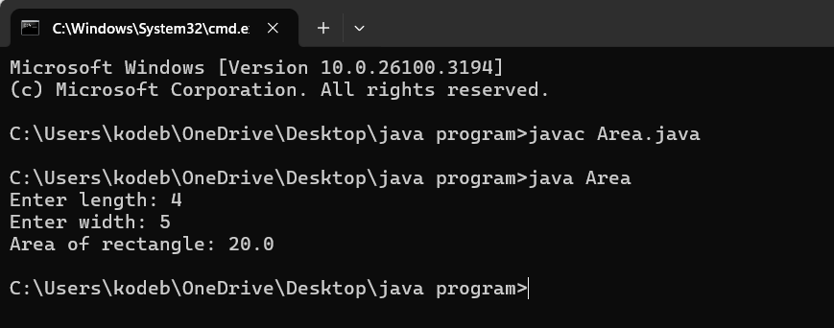

**ERRORS:**

|  |  |
| --- | --- |
| Error found | Error rectified |
| Area.java:7: error: cannot find symbol  float l = inputnextFloat();  ^  symbol: method inputnextFloat()  location: class Area | float l = input.nextFloat(); |

**CODE:**

public class Areat {

public static void main(String[] args) {

double s1, s2, s3;

double area, resArea;

s1 = 35.0;

s2 = 8.0;

s3 = 38.0;

area = (s1+s2+s3)/2.0d;

resArea = Math.sqrt(area* (area - s1) * (area - s2) * (area - s3));

System.out.println("Area of Triangle = " + resArea);

}

}

**OUTPUT:**

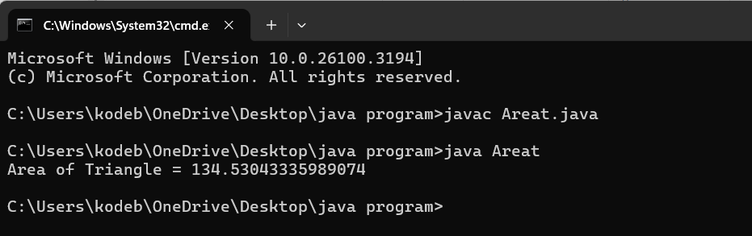

**ERRORS:**

|  |  |
| --- | --- |
| Error found | Error rectified |
| Areat.java:5: error: ';' expected  double area resArea;  ^  Areat.java:5: error: not a statement  double area resArea;  ^ | double area, resArea; |

**PROGRAM-2:**

**AIM:** Write a Java program to convert temperature from Fahrenheit to Celsius and vice versa.

**CODE:**

import java.util.Scanner;

class Temperature {

public static void main(String[] args) {

Scanner input = new Scanner(System.in);

System.out.print("Enter Temperature in Fahrenheit: ");

float F = input.nextFloat();

input.close();

float C = (F - 32)*5/9;

System.out.println("Temperature in celsius: " + C);

}

}

**OUTPUT:**

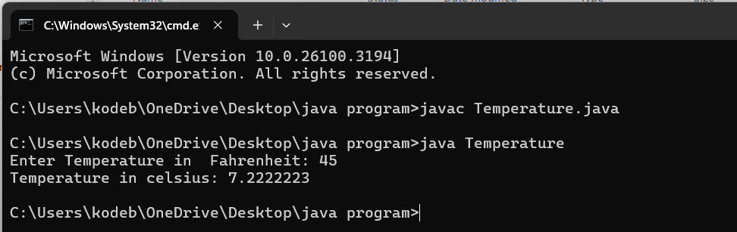

**ERRORS:**

|  |  |
| --- | --- |
| Error found | Error rectified |
| S should be capital in System.out.print | System.out.println("Temperature in celsius: " + C); |

**CODE:**

import java.util.Scanner;

class temperature2 {

public static void main(String[] args) {

Scanner input = new Scanner(System.in);

System.out.print("Enter Temperature in Celsius: ");

float C = input.nextFloat();

input.close();

float F = (C * 9/5) + 32;

System.out.println("Temperature in Fahrenheit: " + F);

}

}

**OUTPUT:**

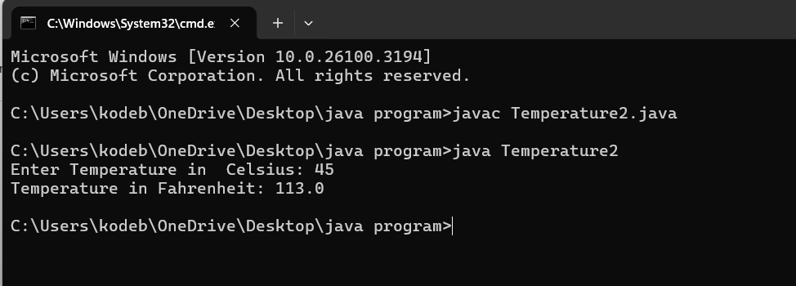

|  |  |
| --- | --- |
| Error found | Error rectified |
| Temperature2.java:13: error: package system does not exist  system.out.println("Temperature in Fahrenheit: " + F); | System.out.println("Temperature in Fahrenheit: " + F); |

**PROGRAM-3:**

**AIM:** Write a Java program to calculate simple intrest.

**CODE:**

import java.util.Scanner;

class Simpleinterest {

public static void main(String[] args) {

Scanner input = new Scanner(System.in);

System.out.print("Enter principle: ");

float P = input.nextFloat();

System.out.print("Enter time: ");

float T = input.nextFloat();

System.out.print("Enter rate: ");

float R = input.nextFloat();

input.close();

float SI = (P*T*R)/100;

System.out.println("simple_interest : " + SI );

}

}

**OUTPUT:**

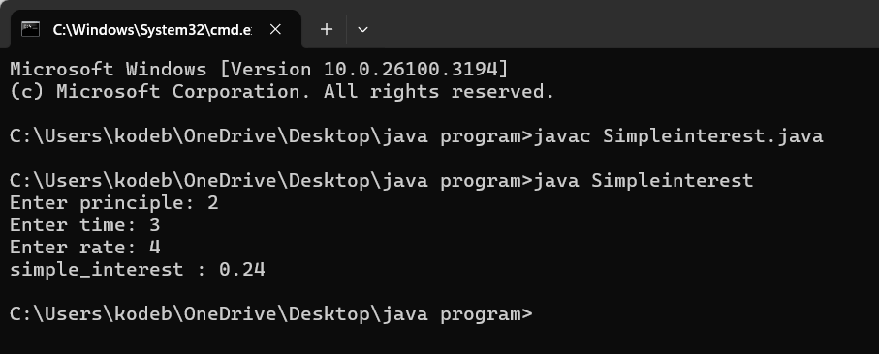

**ERROR:**

|  |  |
| --- | --- |
| Error found | Error rectified |
| Simpleinterest.java:9: error: unclosed string literal  System.out.print("Enter time: );  ^ | System.out.print("Enter time: "); |

**PROGRAM-4:**

**AIM:** Write a Java program to calculate factorial of a number.

**CODE:**

import java.util.Scanner;

public class Factorial {

public static void main(String[] args) {

Scanner input = new Scanner(System.in);

System.out.print("Enter number: ");

int n = input.nextInt();

input.close();

long factorial = 1;

for (int i = 1; i <= n; i++) {

factorial *= i;

}

System.out.println("Factorial of " + n + " is: " + factorial);

}

}

**OUTPUT:**

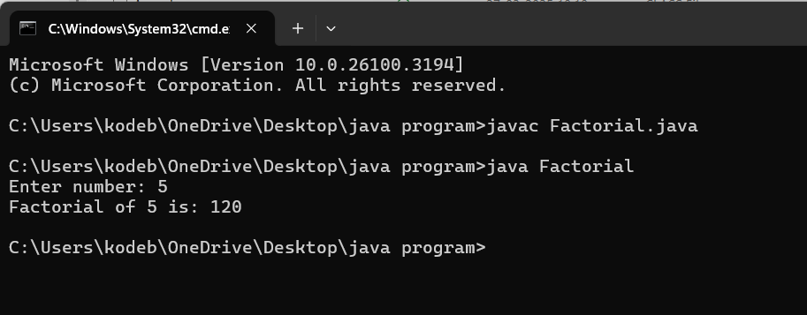

**ERROR:**

|  |  |
| --- | --- |
| Error Found | Error rectified |
| Factorial.java:2: error: class, interface, enum, or record expected  Public class Factorial {  ^ | public class Factorial { |

**PROGRAM-5**

**AIM:** To Write a java program on Fibonacci series

**Code:**

import java.util.Scanner;

public class Fibonacci {

public static void main(String[] args) {

Scanner scanner = new Scanner(System.in);

System.out.print("Enter the number of terms: ");

int terms = scanner.nextInt();

long firstTerm = 0, secondTerm = 1;

System.out.println("Fibonacci Series up to " + terms + " terms:");

for (int i = 1; i <= terms; ++i) {

System.out.print(firstTerm + " ");

long nextTerm = firstTerm + secondTerm;

firstTerm = secondTerm;

secondTerm = nextTerm;

}

}

}

**OUTPUT:**

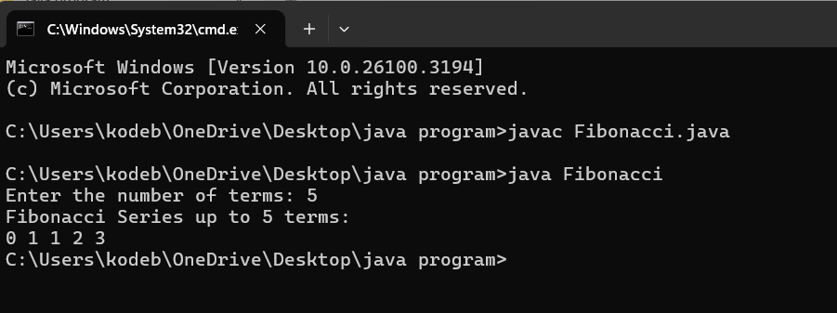

**ERRORS:**

|  |  |
| --- | --- |
| Error found | Error rectified |
| Fibonacci.java:7: error: ';' expected  int terms = scanner.nextInt()  ^ | At the end int terms = scanner.nextInt() this line we should keep ; |

**WEEK 03**

**PROGRAM-1:**

**AIM:** Write a java program with

1.A class with name Car

2.Create 4 attributes named car_colour ,car_brand,fuel_type,milege